Project Design Phase-I
Solution Architecture

Date | 19 September 2026
Team ID | Individual
Project Name | EV Market Performance & Sustainability Analytics
Maximum Marks | 4 Marks

Solution Architecture:
Solution architecture is a complex process – with many sub-processes – that bridges the gap between business problems and technology solutions. Its goals are to:
- Find the best tech solution to solve existing business problems.
- Describe the structure, characteristics, behavior, and other aspects of the software to project stakeholders.
- Define features, development phases, and solution requirements.
- Provide specifications according to which the solution is defined, managed, and delivered.

Sample Solution Architecture Diagram:
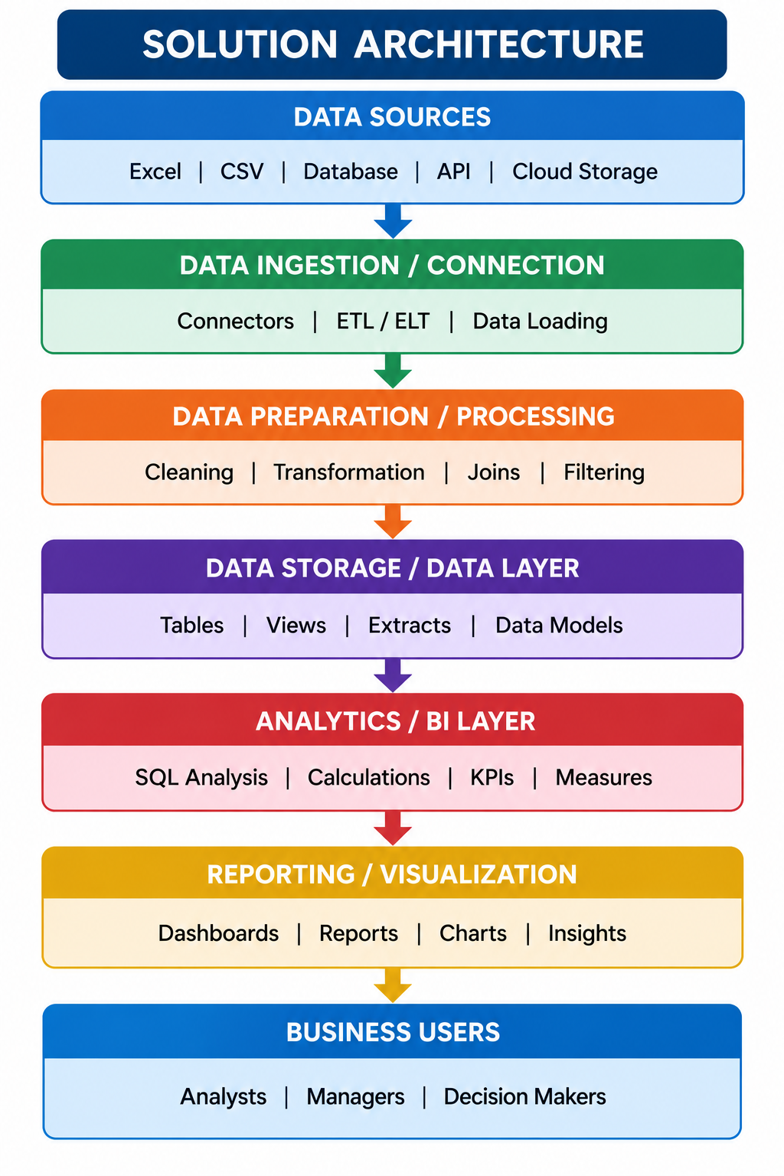

Component Description Table
Component Name | Description / Role in Architecture | Technology Used

EV MARKET ANALYTICS — SOLUTION ARCHITECTURE
End-to-end flow of the current Tableau dashboard implementation
1. DATA SOURCE
Supplied EV market CSV / Excel dataset
2. DATA CONNECTION
Tableau Desktop Data Source connection
3. DATA CHECKS & PREPARATION
Verify field types, missing values, category labels, units, and calculations
4. ANALYSIS & CALCULATED MEASURES
SUM sales, AVG price, AVG range, CO2 savings, category and battery sales shares
5. VISUALIZATION LAYER
KPI cards, line chart, country bars, donut charts, manufacturer view, range distribution, heatmap, scatter plot
6. DASHBOARD & INTERACTION
Dashboard layout, filters, tooltips, and chart-selection actions where configured
7. BUSINESS USERS
Market strategy director, business intelligence manager, sustainability researcher
Architecture note: This describes the current file-based Tableau solution. It does not assume a separate database, ETL service, Python pipeline, or live data integration.

